EX12-Create a Virtual Machine with 1 CPU, 2GB RAM and 15GB storage disk using a Type 2 Virtualization Software.

PROCEDURE:

Step1: create a new virtual machine

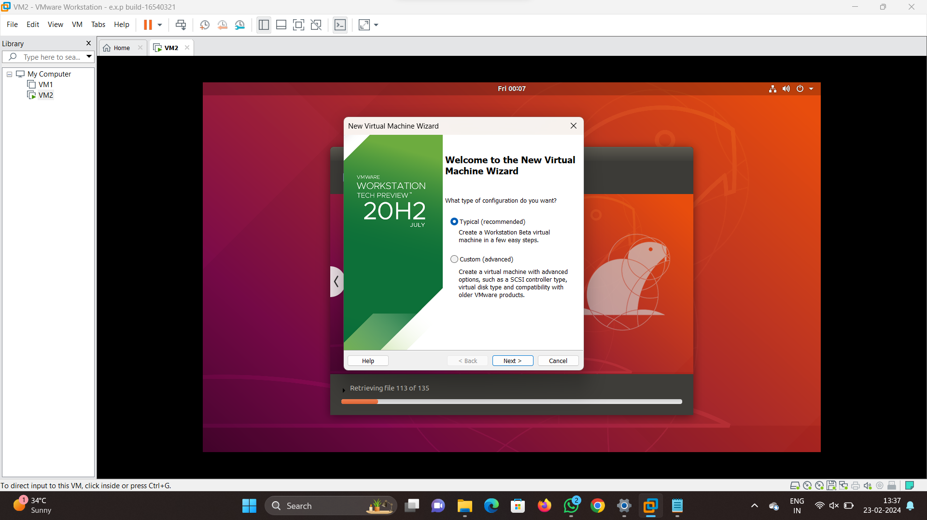

Step2:select whether to connect the guest os or not

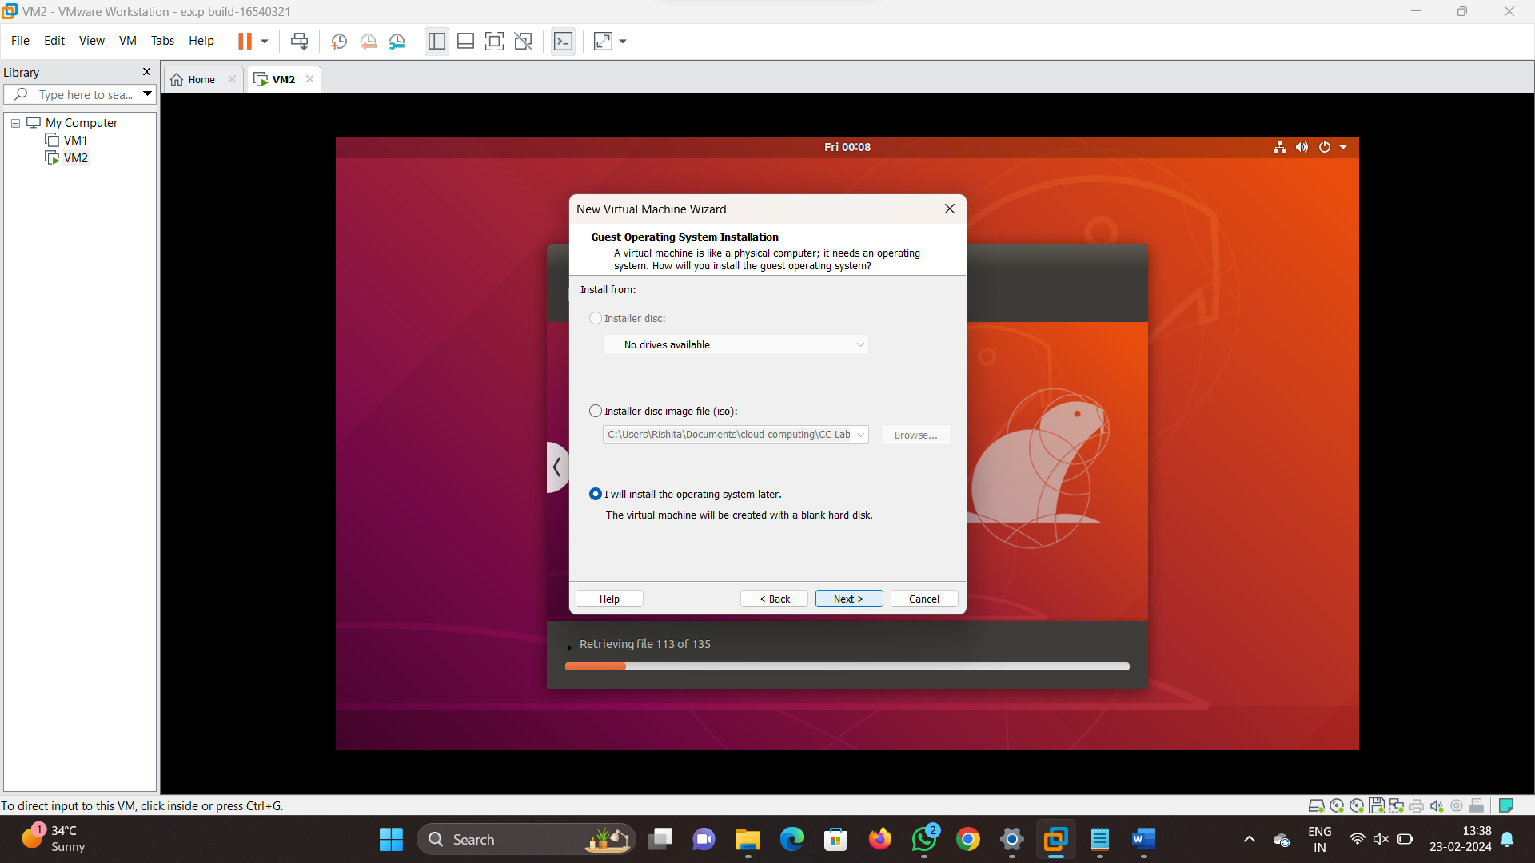

Step 3:Give name for the virtual machine

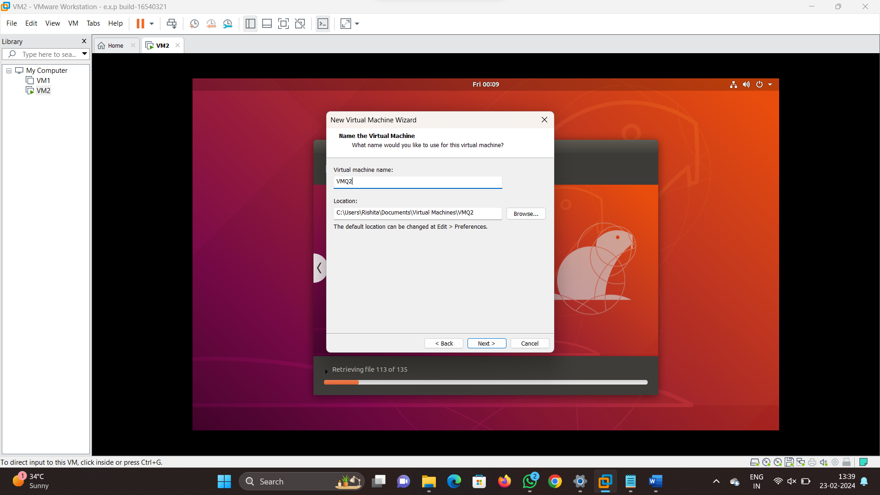

Step 4: give the configurations as mentioned in the question

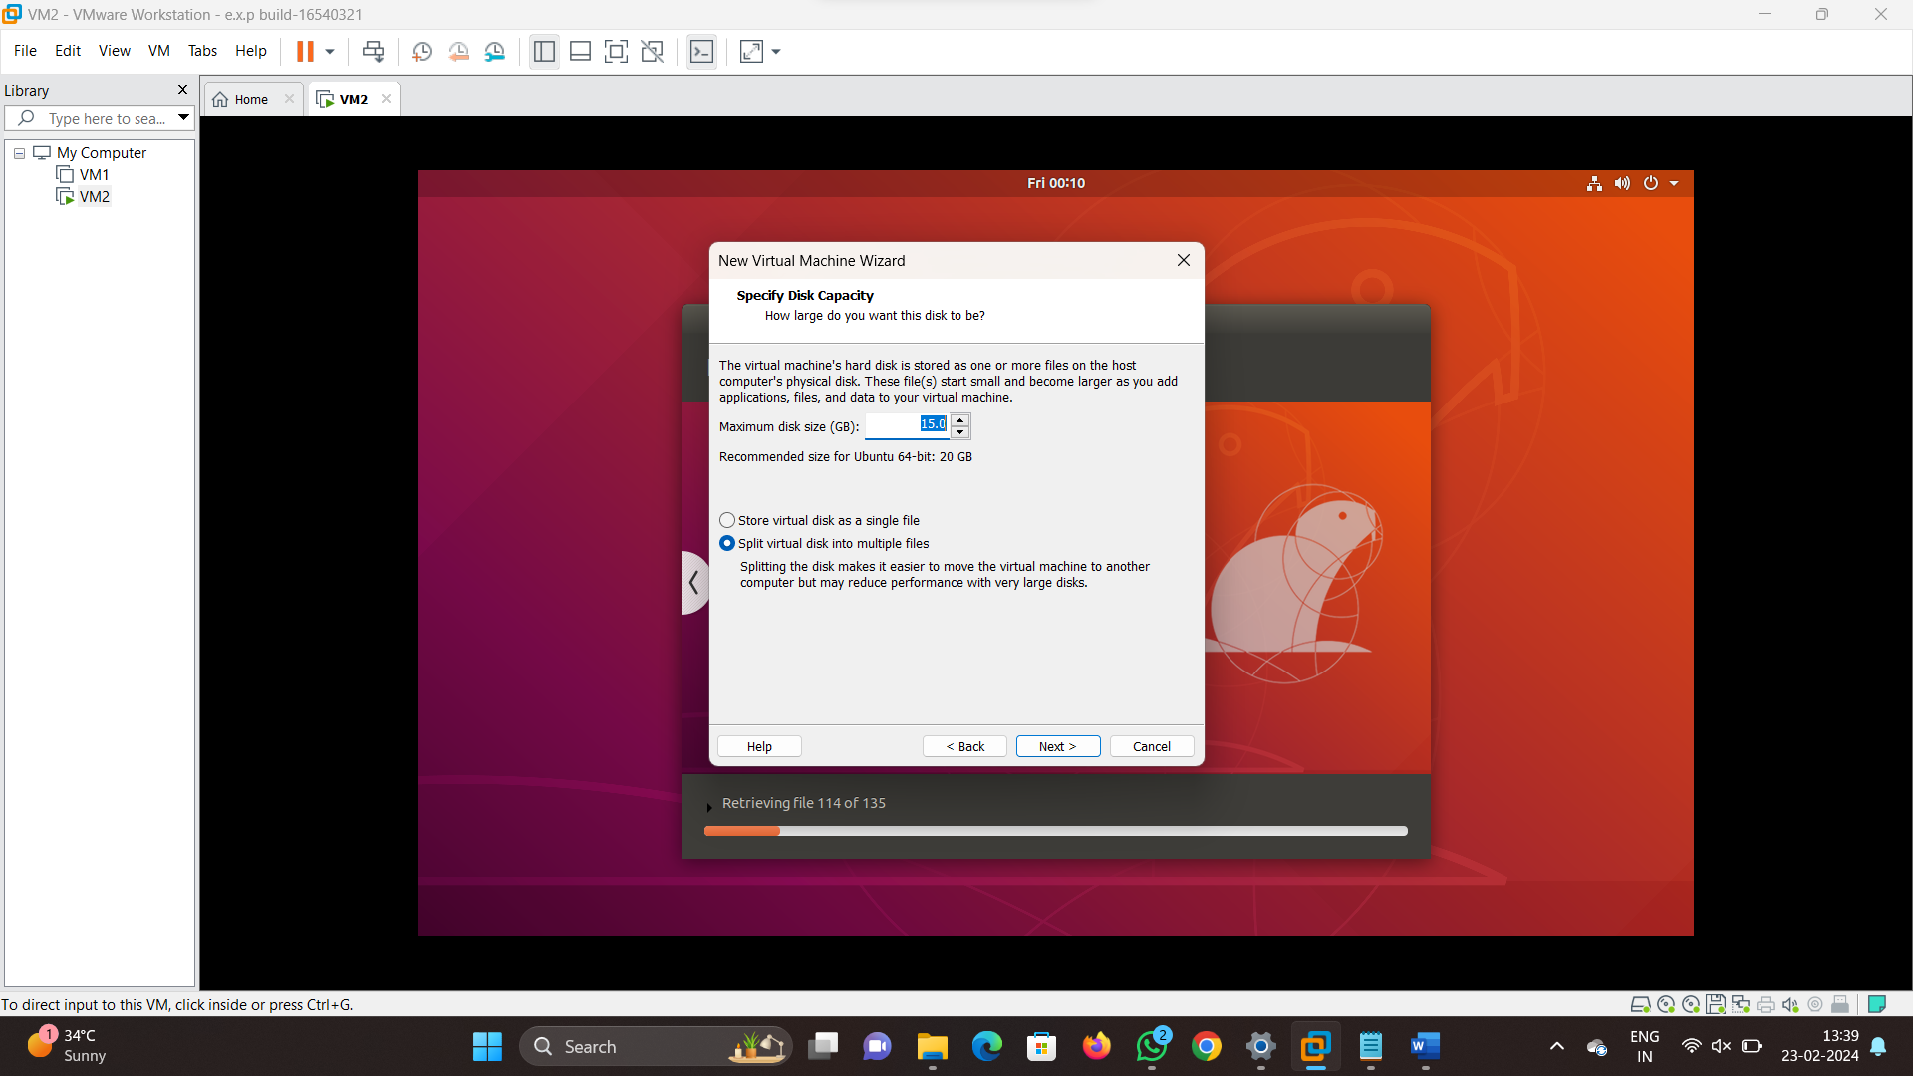

Step 5: recheck the configurations given and click on finish

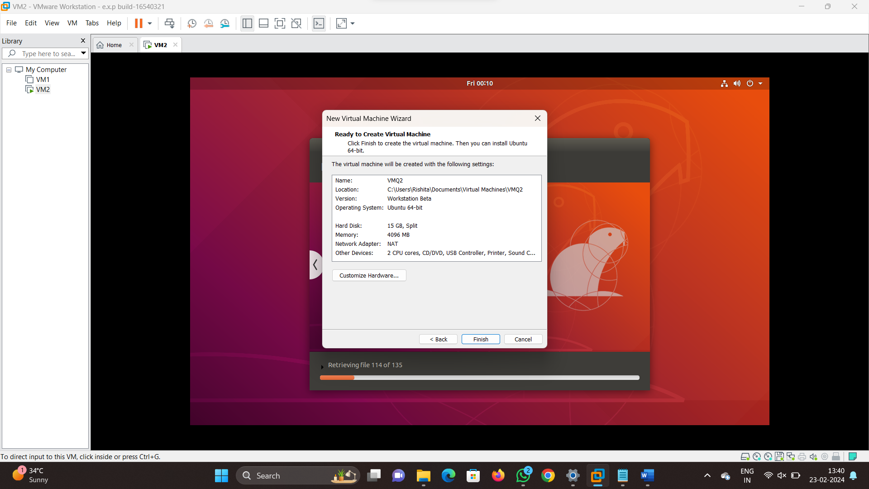

Step 6:virtual machine is created with the required configuration

